**Introduction**

**Welcome**

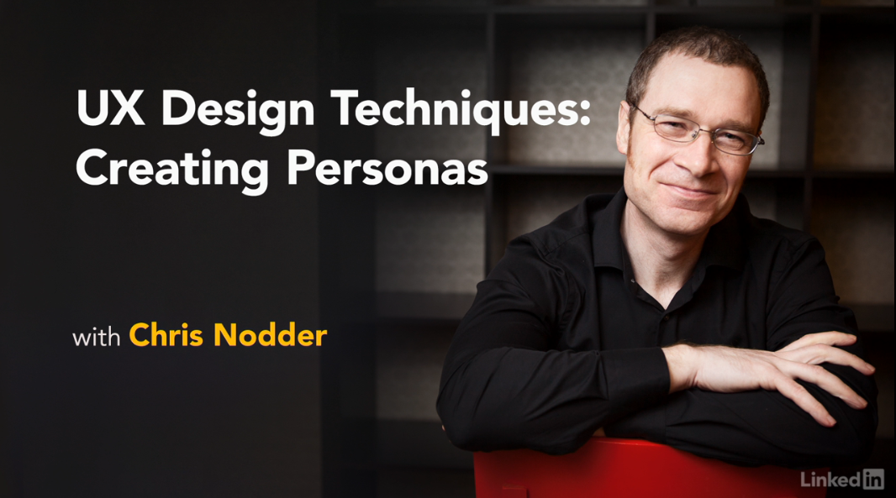

[Hello, I'm Chris Nodder. Welcome to the third installment of the UX Design Techniques series. In this episode, we'll discuss creating personas. I'll show you how to use the data you've gathered from your site visits and from other customer interactions to build a picture of the users you care most about. Having this common understanding will make sure the whole team is designing for the same people, so the interface feels coherent and focused. Now it's time to dive in and create some initial descriptions of your target users, so let's get started.](https://www.linkedin.com/learning/ux-design-3-creating-personas/welcome?resume=false)

1. **Personas in the User-Centered Design (UCD) Process**

**What is a persona?**

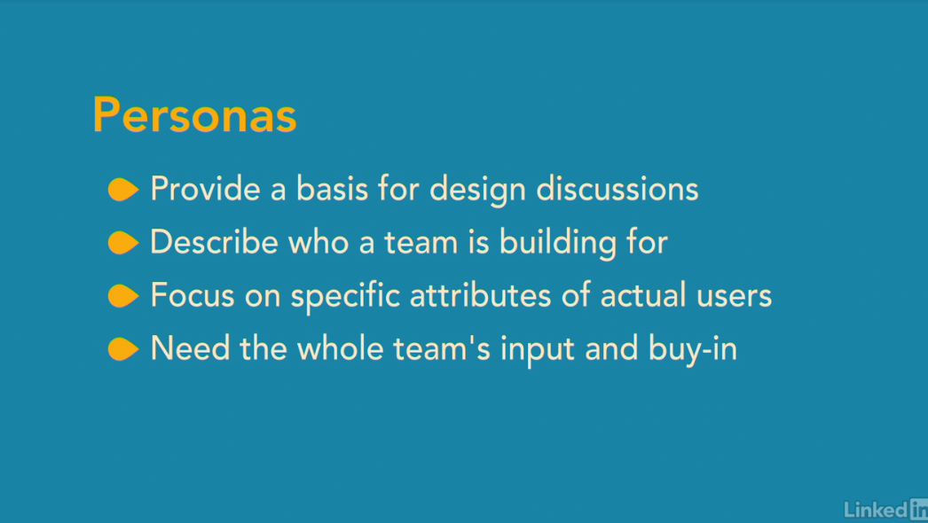

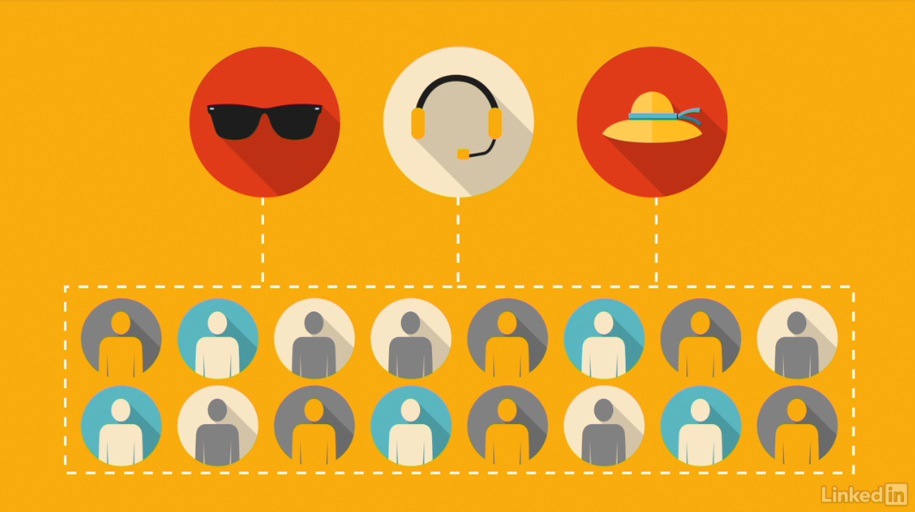

[Personas are imaginary, yet realistic and detailed descriptions of the users of your product. They provide a basis for design discussions by concentrating many pieces of user data into key focused, believable descriptions of your primary audience. Creating personas gives the team a shorthand way of describing who they're building things for. Rather than saying, the user, which could mean anyone. To focus on some set characteristics with specific attributes means that product development takes those personas's needs into account. The whole team needs to buy into the concept of personas. The easiest way to ensure they agree on the key attributes is to get everyone involved in creating the personas to start with. Now, how can just a few fake people be sufficient for designing a whole product? As you'll see the personas you create are highly representative of your key users. Their value is in the focus they give you. Rather than trying to be all things to all people, this focus will mean you deliver a streamlined product with a consistent message. What's really interesting about persona-based design is that, although you're only designing for a couple of key individuals, the vast majority of your user base is likely to share the same needs, or at least be able to work with the same features. So by focusing clearly on the requirements of a small group of users, you actually build a better product for all your customers.](https://www.linkedin.com/learning/ux-design-3-creating-personas/what-is-a-persona?autoSkip=true&resume=false)

**How personas fit into UCD**

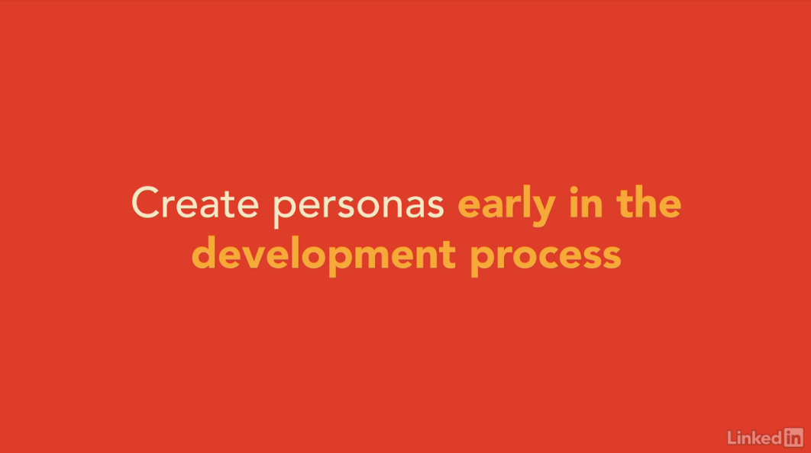

[Personas are created from site visit data in order to focus future design and development efforts. They're essential for ideation, scenario creation, prototype development, and for recruiting the correct user types for prototype usability testing. You can create personas at any time during the development process, but the earlier you do it, the more benefit you'll get from the focus the personas provide. The best time to introduce personas is just after you've finished analyzing your site visit data when the site visits are still fresh in team members' minds. Hopefully, you already conducted site visits with people who you think are representative users or potential users of the product you'll be building. That means their attributes and behaviors are likely to be representative of the attitudes, skill level and background knowledge that you expect in your general user base, so you can use data from your site visits as one input to the personal creation process. As we described in the analyzing data course earlier in this series, part of your experience map was set aside for listing user attributes. Now you can revisit that information to help inform your persona creation.](https://www.linkedin.com/learning/ux-design-3-creating-personas/how-personas-fit-into-ucd?resume=false)

**The benefits of personas**

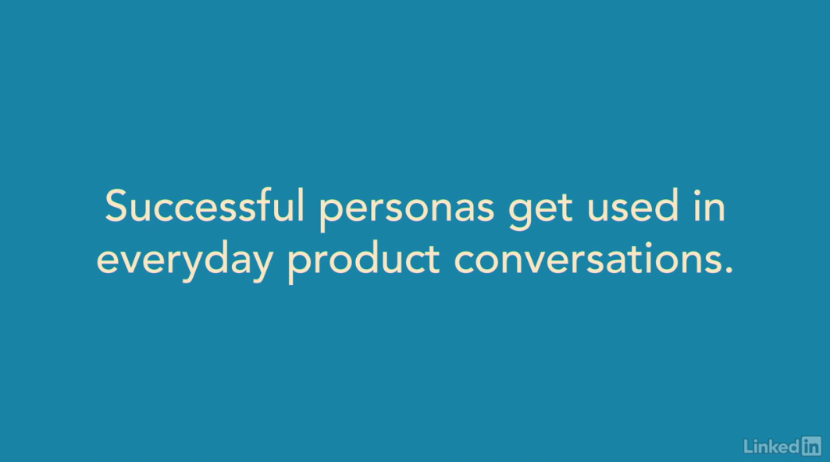

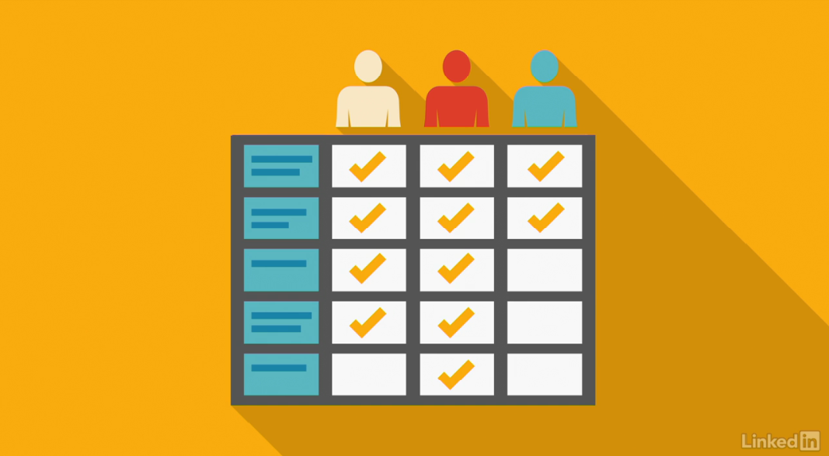

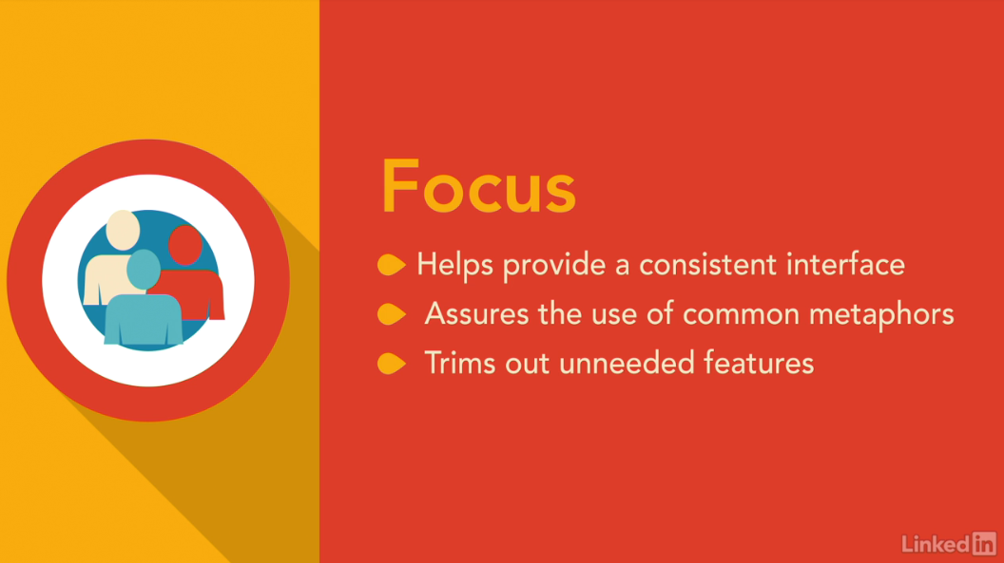

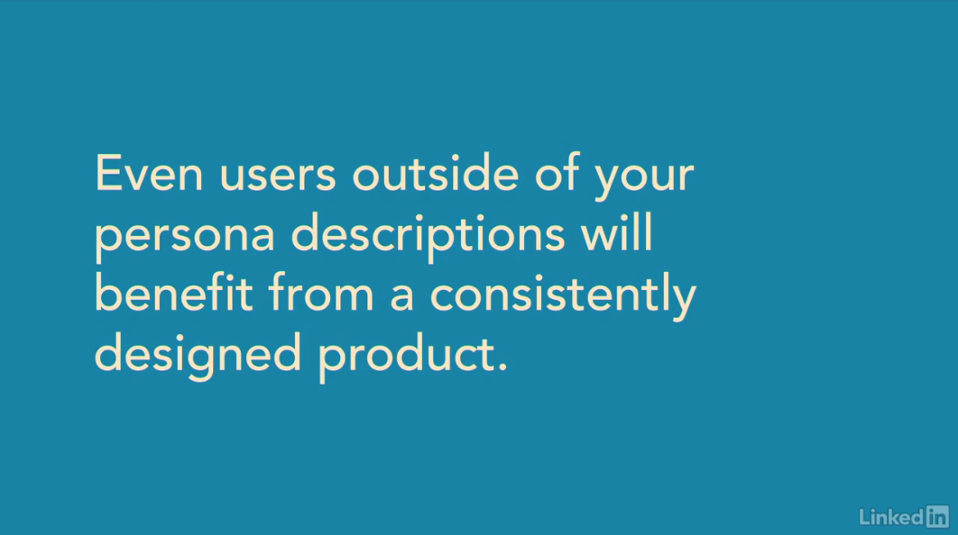

[Personas give everyone on the team a common vocabulary for describing the users you will design and develop for. As a result, decision making is easier and the resulting product is more focused. By common vocabulary I mean that team members can use the personas name as a kind of short hand to describe a set of attributes, desires, and behaviors. The attributes, desires, and behaviors are well enough defined that by using the personas name everyone in the conversation immediately knows how that persona might respond to the interface you're developing. In fact, it's a sign that your personas are successful when team members start using the personas names in their everyday conversations about the product. For instance, saying, "Yes, George would want it to behave like that," or, "No, Jesse wouldn't expect "to see that type of interaction here." Having clearly stated persona attributes also helps in decision making. You might be wondering how important each of a set of new potential features would be to your users. It's easy to take what you know about your personas and use that as a way of prioritizing the different features. If your personas are clearly defined, everyone on the team should be able to agree about which features will provide the most benefit for those personas, and so, which features you should give priority to. And building your product for a set of well defined personas means it will have a focus that would be lacking otherwise. That focus is important, because it makes sure the interface behaves consistently, uses common metaphors, doesn't jump between being aimed at novices and being aimed at experts, and doesn't include just in case features. You know the type of thing I mean, a menu option or other functionality that's put into the product just in case there's one user out there who might want it. Having a defined group of target users means that just in case features can be removed from the priority list, because they wouldn't be useful to your personas. That ability to streamline the product alone is worth the small investment in creating personas. Even if not every user matches your persona description, they will all appreciate the cleaner design that persona focused development allows you to create. Next, I'll explain how to create some simple initial assumption personas, which should be good enough to get you started on the development path.](https://www.linkedin.com/learning/ux-design-3-creating-personas/the-benefits-of-personas?resume=false)

1. **Persona Creation**

**Elastic vs. concrete users**

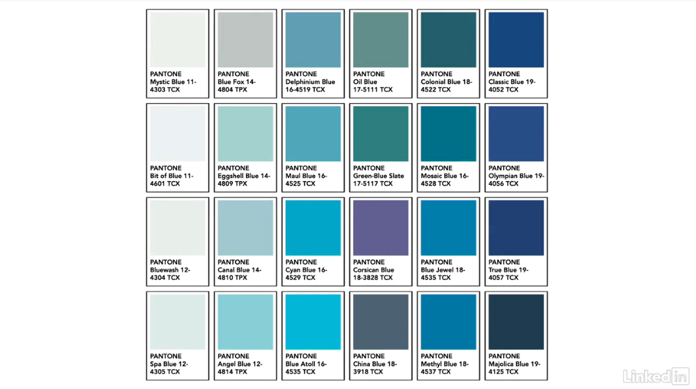

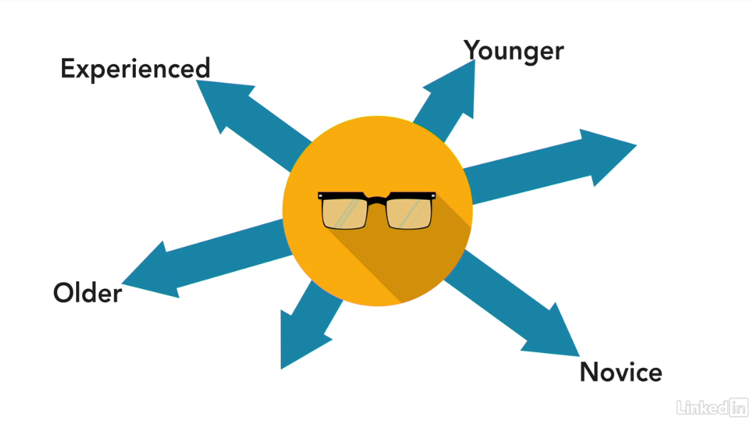

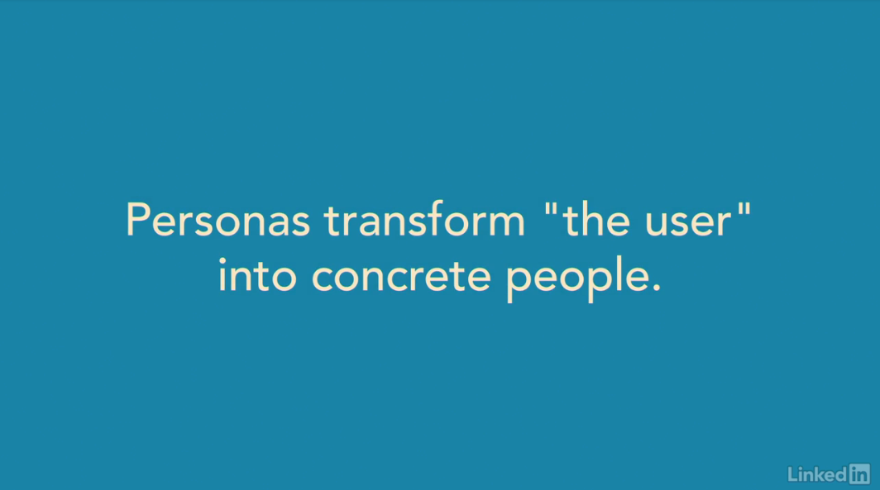

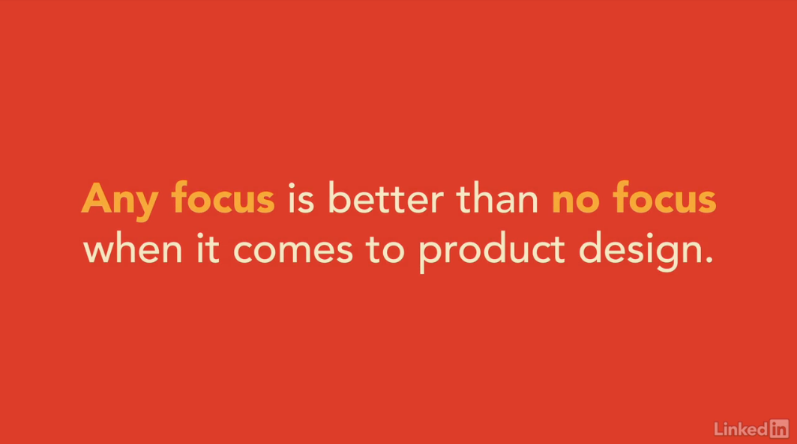

I[f you asked everyone on the team to think of the color blue, and then showed each of them a selection of Pantone color swatches, how many of them do you think would choose the same swatch? It's the same thing when we ask the team to think about the user. Each of them has a different picture of who the user is. If you're lucky, it's the last customer they saw. If you're unlucky, it's more likely to be the generic "my mom." When you build software, that user description gets stretched in many directions. Sometimes, someone on the team suggests that the user is experienced. Sometimes, they aren't. Sometimes, they're older. Sometimes, they're just out of college. The result is a product that aims at different users at different points in the interaction. Real users aren't made of elastic. They find it hard to cope with our schizophrenic interfaces. Personas let the whole team get on the same page. By creating an explicit persona, you make the concept of "the user" concrete rather than elastic. Even if the persona you created is slightly different from each real-end user, your customers will much prefer a consistent interface over an inconsistent one. Any focus is better than no focus when it comes to product design. Products that don't tell a clear story are harder to learn and harder to use. By building a product around key persona's needs, you give it that focus. In the next video, we'll talk about the easiest type of personas to make: assumption personas.](https://www.linkedin.com/learning/ux-design-3-creating-personas/elastic-vs-concrete-users?autoSkip=true&resume=false)

**Create assumption personas**

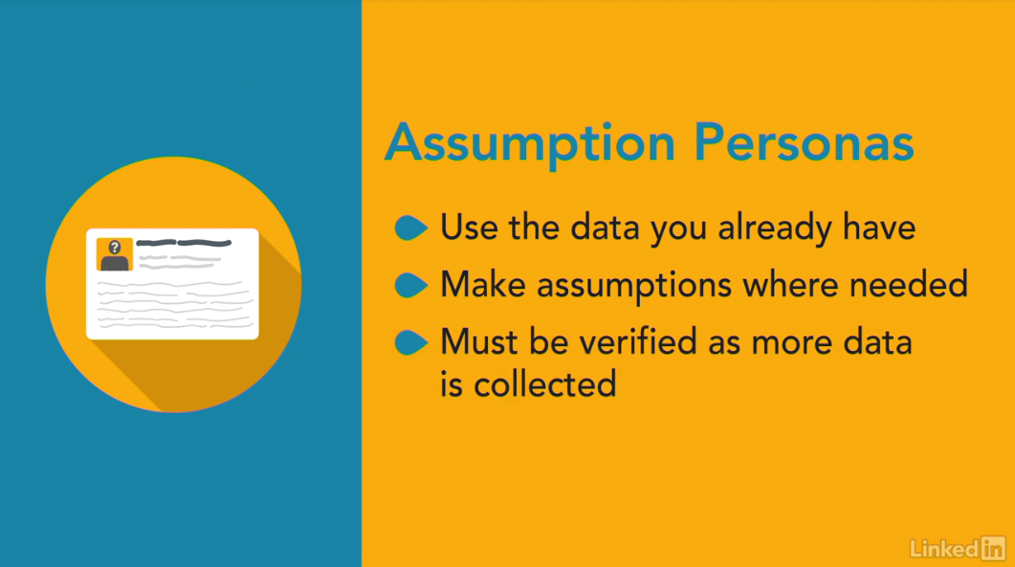

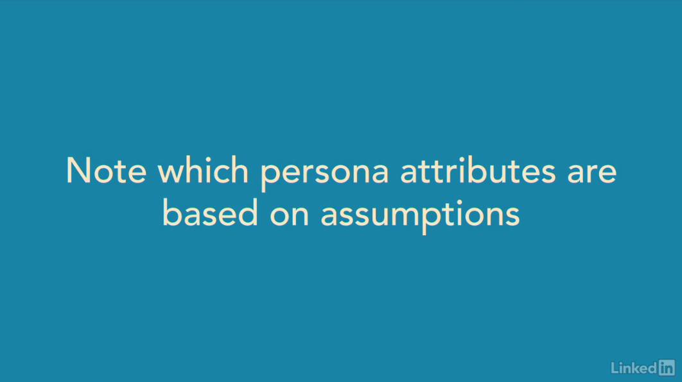

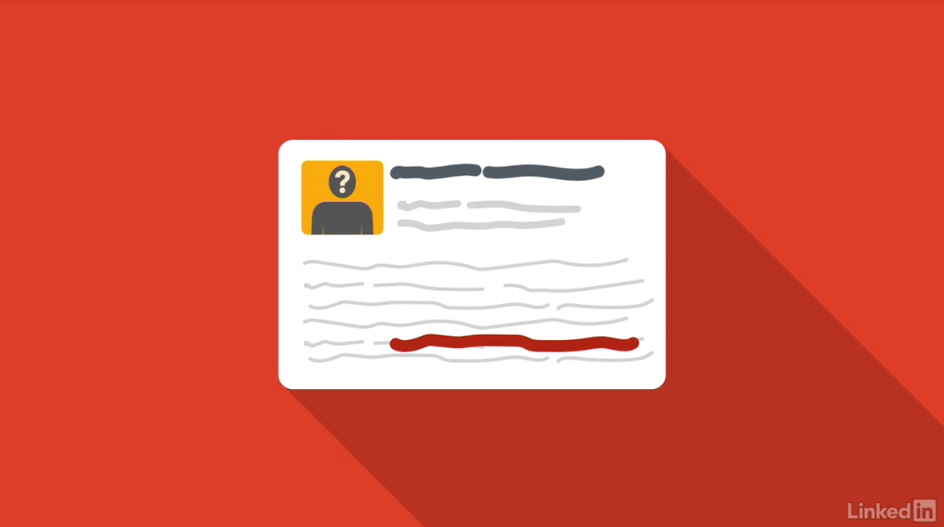

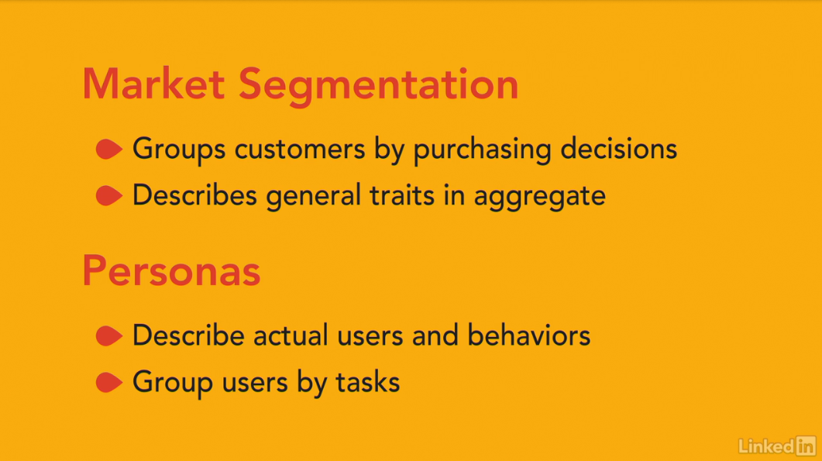

[At this point in your design process, you might not have a large amount of data about your users, however, you can still build personas based on a combination of the data that you do have, and some assumptions that you make about your user base. The important thing, is to make the assumptions clear, and to talk them through with other team members, this helps you reality-check your assumptions, and then follow up with more data collecting activities, to flush out your assumptions later. The important thing, is to note which persona attributes are based on assumptions. Later on, when we recruit users for usability testing based on these persona descriptions, it will give us an opportunity to test our assumptions, and work out whether our personas need to be tweaked at all. This way, you always have a working model of your personas, and you make small course corrections over time, as you learn more about your users' needs. It's worth mentioning here that personas aren't the same thing as market segmentation. Market segmentation divides customers by the type of purchasing decisions they make. For instance, are they cost-conscious, or early adopters? Market segmentation forms groups using similarities based on statistical attributes, and it's primarily used to create product differentiation strategies, such as pricing, and features. It describes types of customers in aggregate format. In comparison, personas describe actual users and their behaviors, however fictional the individual really is. Personas are based on the tasks that people want to perform with the product, and they are used primarily for feature creation strategies, such as deciding what features fit with user needs. Market research data can still be really useful for persona creation, but personas are focused more on the creation phase, than the selling phase of product development. So, next, we'll look into more detail at the process of creating assumption personas.](https://www.linkedin.com/learning/ux-design-3-creating-personas/create-assumption-personas?resume=false)